*Autor: RinGO_01 Version: 2.0 alpha*

# What you Need

1. HxDEditor (To Copy partition tables)
2. WinHex v19.3 (To Copy OSPool)
3. WPInternals 2.9.2 (To Unlock Bootloaders)
4. OTCUpdater (To update phone from 10586 to 14393)
5. DiskGenius (To Copy EFIESP, Also You can try some similar tools)
6. EFIESP.pmf backup extract from VHDX files
7. Files Shared By Gus33000
   1. The VHDX file convert from the ffu shared by orangera1n
   2. UnlockedGPT.bin & ReplacementForProd-20240902T234110Z-001.zip

# How To Do

1. Flash (via WDRT or similar software) original ffu back to 10.0.10586. And then update (via OTCUpdater) the phone to 14393.
2. Unlock Bootloader via Wpinternals 2.9.2.（**Note: Only unlock bootloader**）
3. Manually enter mass storage mode. You can choose to back up a full disk image via winimage32.
4. Run HxD as an administrator and open UnlockedGPT.bin. Click the "Tools" option and then click "Options".Under "Security", uncheck"Open disks as readonly by default" and click "OK".

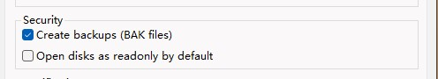

1. Click the "Tools" -> "Open disk".Select "MSFT PHONE MMC Stor" to Read.
2. Copy the hexdecimal data from line "00000000" to line "000017F0" of the "UnlockedGPT.bin" and paste it to the same location of the phone's drive. And LIne"000017F0" should be the last line of "Sector 11".
3. Once finished, press ctrl+s to save. Exit HxD and open "diskmgmt.msc".
4. Select Mobile Disk and "Action" -> "Fresh".
5. Use DiskGenius to flash EFIESP.pmf to the EFIESP partition of the phone(Maybe Name ESP).

Then exit DiskGenius.

1. Take the phone's disk "Offline" :

Run "CMD" as an administrator.

diskpart

lis dis

sel dis # # is your phone disk

offline disk

attr disk clear readonly

1. Double-click the VHDX file to mount it.
2. Run WinHex as an administrator and click "Tools" -> "Disk Tools" ->"Clone disk...". (*If winhex becomes unresponsive at this point, unplug your phone, wait for the winhex pop-up window to appear, and plug it in again.)*
3. Select "**Msft Virtual Disk** " as the source disk and "**MSFT PHONE MMC Stor**" as the destination disk. **DO NOT** Choose "Copy entire medium" but enter "**8720384**" as the "*Start sector(source)*" and "*Start sector(destination)*" and enter "**52348928**" as "*Number of sectors to copy*",Keep the rest of settings as default and click "OK" to start, and Wait for about two hours. (*During this process, winhex may become unresponsive, please be patient with it.*)

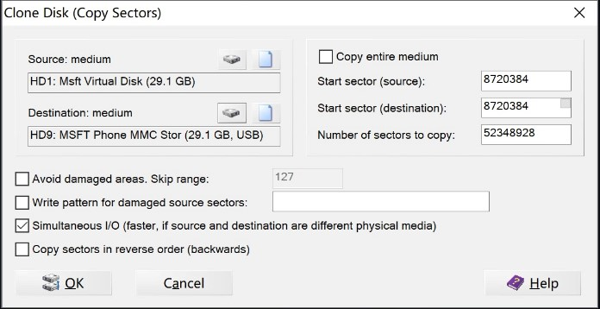

1. After completition, detach the vhdx file(*You can simply right click on "HACK_EFIESP" in Explorer and click "Eject"*).
2. Take the phone's disk "Online"

Run "CMD" as an administrator

diskpart

lis dis

sel dis # # is your phone disk

online disk

1. Disconnect the phone from PC and reconnect it. Copy "qcdsp1v28992.mbn" and "qcdsp28992.mbn" extracted from "ReplacementForProd-20240902T234110Z-001.zip" to "MainOS:\Windows\System32" and replace the original files.
2. Boot and hope for the best!

# Notes

1. If the phone is shut down before and after copying OSPool, use an SD Card to boot into mass storage mode instead of Windows Phone Internals.
2. When copying and replacing the two MBN files, **DO NOT** use DiskGenius.
3. OSpool seems to contain a time bomb, so please try not to reboot or change the time.

If your phone keeps loading instead of going to the desktop after restarting, try the following steps:

* 1. Use an SD Card to boot into Mass Storage mode.
  2. Run DiskGenius and flash the HACK_EFIESP.pmf , Data.pmf , OSData.pmf and

PreInstalled.pmf Extracted from VHDX Files to the corresponding partitions in OSPool.

* 1. Hope for the best again. : )

# Credits

1. Ritsu_909: He told me how todo it. [Github Page](https://github.com/Ritsu909/Andromeda_17686)
2. Gus_33000: He shared several files and tools to help.
3. OrangeRa1n: She shared the Image files of Andromeda.
4. Empyreal96: He taught me a lot of theoretical knowledge.
5. Steve_246: He gave me a Retail Lumia 950 to test this method.
6. Abc145: : He taught me a lot of practical knowledge
7. And everyone who works hard for Windows Phone. :)

* Mediaexplorer74